 **Avionics Internship**

**Topic: Angle of the nose wheel**

**Anirav Jain**

The main objective of the project is to find the angle of the nose wheel of an aircraft by using a RVDT, a goertzel filter and a control loop. The nose wheel is a wheel located under the nose of an airplane which is a part of the plane’s landing gear that can move from -85° to +85 °. A rotary variable differential transformer (RVDT) is a type of electrical transducer which is used to measure the angular displacement of the nose wheel. The output of the RVDT is then fed to an ADC which samples the analog signal and feeds it to a goertzel filter to remove the unwanted noise signals picked up. The output of the goertzel filter gives the angle observed by the RVDT and that is fed into a first order closed control loop which compares the RVDT angle with the command angle received from the Remote Electronic Unit (REU) on the aircraft. The job of the control loop is to remove the error between the nose wheel angle and the REU command angle by moving the nose wheel in the direct of the REU command angle. Each block of the system is discussed in detail in the following paragraphs.

Basic RVDT construction and operation is provided by rotating an iron-core bearing supported within a housed stator assembly. The shaft of the iron-core bearing is essentially connected to the nose wheel. The stator consists of a primary excitation coil and a pair of secondary output coils. A fixed alternating current excitation at a particular frequency is applied to the primary stator coil that is electromagnetically coupled to the secondary coils. This coupling is proportional to the angle of the input shaft. When the rotor is in a position that directs the available flux equally in both coils, the output voltages cancel (Va = Vb so Va-Vb= 0) and result in a zero value signal. This is referred to as the electrical zero position or E.Z. When the rotor shaft is displaced from E.Z., the resulting output signals have a magnitude and phase relationship proportional to the direction of rotation. Because RVDTs perform essentially like a transformer, excitation voltages changes will cause directly proportional changes to the output (transformation ratio). However, the voltage out to excitation voltage ratio will remain constant. For the particular RVDT we are using, the primary is excited at a frequency 1923 Hz at a voltage of 5V rms. The transformation ratio i.e. Vout/Vin = (Va + Vb)/Vin = 0.75 therefore (Va +Vb) = 0.75*5 = 3.75 V rms which is a constant. We now need the ratio-metric sensitivity which is (Va-Vb)/degree. According to the RVDT equation, degree (ɵ) = (1/G)*(Va - Vb)/ (Va+Vb) so the ratio-metric sensitivity (Va-Vb)/degree = (Va+Vb)*G. G is the sensitivity which has the value 0.0088 V/deg rms and earlier we have found that (Va+Vb) is a constant which has the value 3.75 rms therefore the ratio-metric sensitivity is 3.75*0.0088 = 0.033 V/deg rms.

Once the secondary of the RVDT generates a signal corresponding to the angle, it is fed into an ADC with a sampling frequency of 24992 Hz. During the coupling process, the signal picks up noise therefore the signal obtained at the secondary of the RVDT is corrupted with unwanted frequencies. This is why this signal must be filtered to remove the noise. For this project, we have used a goertzel filter as it is computationally very efficient to detect a single tone frequency. The Goertzel Algorithm exploits the periodicity of the phase factor {WNk} and allows us to express the computation of the DFT as a linear filtering operation as WN-kN=1, we can multiply the DFT by this factor. Thus



We note that the above equation is in the form of a convolution. If we define the sequence yk(n) as

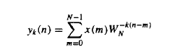

It is clear that yk(n) is the convolution of a finite duration input sequence x(n) of length N with a filter with an impulse response



The output of the filter at n=N yields the value of the DFT at frequency wk = 2*pi*k/N. That is,



Instead of performing the computation of DFT via convolution, we can use difference equations corresponding to the filter given by

w(n) = 2cos(2*pi*k/N)*w(n-1) – w(n-2) + x(n)

y(n) = w(n)-exp(-i*2*pi*k/N)*w(n-1)

Now wk = 2*pi*k/N=2*pi*f/Fs, therefore f/Fs=k/N where f is the frequency to be detected (frequency at which the primary of excited), k is the index of the bin, N is length of the sequence, and Fs is the sampling frequency. In our project, f/Fs*N=k must be determined. We take N as 143 such that f/Fs*N= 1923/24992*143 so that we get k=11 which is an integer. We must always take N such that k is an integer so that we are detecting the frequency at the center of the bin. If we don’t take a bin center frequency, we could pick up other frequency components due to spectral leakage. After filtering, we obtain the amplitude of the signal which corresponds to the particular RVDT angle. This amplitude has both real and imaginary terms (due to the exponential term) but we are only interested in the magnitude. After the magnitude is found, the angle is fed into the control loop.

The main function of the control loop is to eliminate the error between the nose wheel angle and the command angle by moving the nose wheel to the position of the command angle. This is done by finding the difference (the error) between the REU command angle and the observed nose wheel angle and feeding it to a controller. There are many different controllers that can be used such as Proportion Derivative Control (PD), Proportion Integration Control (PID), Proportion Control (P) and Proportion Integration Control (PID). For our project, we have chosen a PD controller. Although the rise time for a PD controller is more than a PI or PID controller, the overshoot and the settling time is also less as compared to the two which is critical for our system. The equation of the control loop is

Output (current) = Kp*error + Kd*(error-previous_error)/T

Kp is error gain which is 2.5 mA/deg

Kd is differentiator gain which is 0.1 mA ms/deg

Previous_error is the error from the last REU frame calculation

T is the REU frame rate which is 8 ms

The controller is then used to power an electro-hydraulic servo valve (EHSV) which controls the nose-wheel angle depending on the amount of current supplied to the valve. The EHSV can’t operate if the current is greater than 20 mA and less than -20 mA and the safe range of operation is -8 mA to 8 mA. This is why if the current crosses 8 mA, it is capped and the nose wheel is moved at a fixed rate. The rate we have assumed for our project is 10 degrees per second. The loop is repeated until the nose wheel angle and the command angle match and hence there is no error.

**Block Diagram**

Kp Angle

Current Limiter

+ Angle

+ Angle

Command Angle

+ Angle

- Angle

Kd Angle

Differentiator

EHSV

Nose Wheel

Mag

1923 Hz Angle

24992 Hz Angle

Goertzel Filter

ADC

RVDT

**Simulation Results**

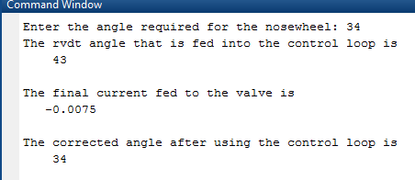

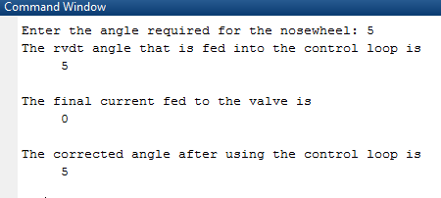

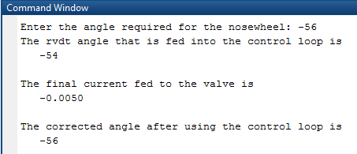

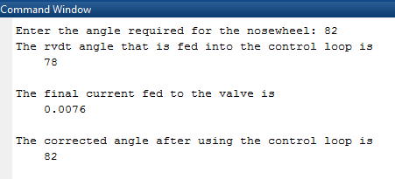

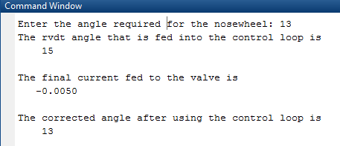

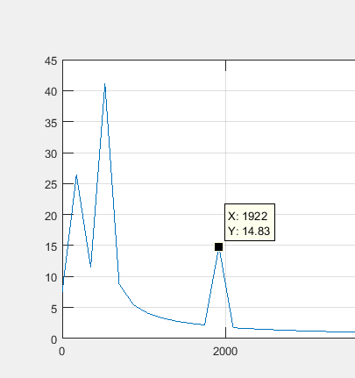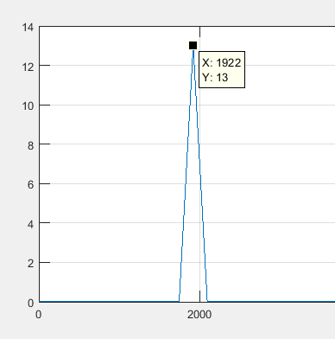

Magnitude Response using fft without noise

Magnitude Response using fft with noise

Degrees

Degrees

Frequency

Frequency

